Project Design Phase-II
Technology Stack (Architecture & Stack)

Date | 18 June 2026
Team ID
Project Name | ShopEZ – MERN Stack E-Commerce Platform
Maximum Marks | 4 Marks

Technical Architecture:
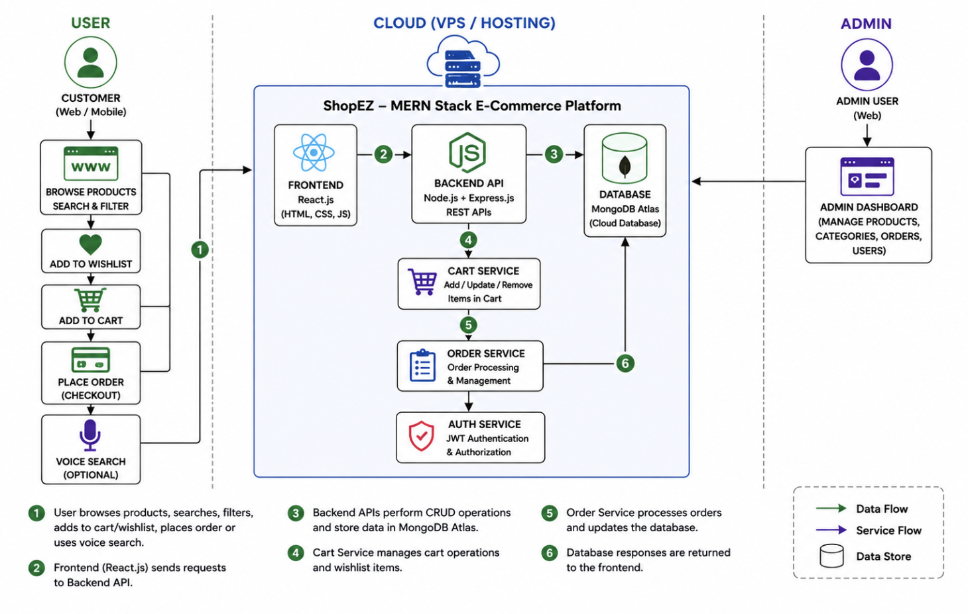

Table-1 : Components & Technologies:
S.No | Component | Description | Technology
1. | User Interface | Web application for customers and administrators | React.js, HTML, CSS, JavaScript
2. | Application Logic-1 | User registration, login, authentication, and authorization | Node.js, Express.js, JWT
3. | Application Logic-2 | Product listing, search, filtering, and wishlist management | Express.js REST APIs
4. | Application Logic-3 | Shopping cart, quantity management, and order processing | Node.js, Express.js
5. | Database | Stores users, products, wishlist, cart items, and orders | MongoDB
6. | Cloud Database | Database hosting and management | MongoDB Atlas
7. | File Storage | Product image URLs and image references | Cloud Image URLs
8. | External API-1 | HTTP requests between frontend and backend | Axios
9. | External API-2 | Authentication and authorization tokens | JWT
10. | Machine Learning Model | Not Applicable | N/A
11. | Infrastructure (Server / Cloud) | MERN Stack deployment environment | Local Server / Cloud Deployment

Table-2: Application Characteristics:

S.No | Characteristics | Description | Technology
1 | Open-Source Frameworks | Frontend and backend frameworks used in ShopEZ | React.js, Node.js, Express.js, MongoDB
2 | Security Implementations | User authentication, authorization, and protected admin routes | JWT Authentication, Password Hashing
3 | Scalable Architecture | Three-tier MERN architecture supporting future growth | MERN Stack Architecture
4 | Availability | Accessible through web browsers anytime and anywhere | Node.js Server + MongoDB Atlas
5 | Performance | Fast product search, filtering, and API responses | Express.js, MongoDB Indexing
6 | Reliability | Consistent access to products, cart, wishlist, and orders | MongoDB Atlas, REST APIs
7 | Maintainability | Modular code structure for easy updates and debugging | React Components, Express Routes
8 | Compatibility | Supports modern browsers and multiple devices | Chrome, Firefox, Edge, Safari
9 | Data Integrity | Accurate storage and retrieval of user, product, and order data | MongoDB Database

